TERRAFORM FINAL CHALLENGE
1.Create VPC
Objective
To create a Virtual Private Cloud (VPC) that provides an isolated networking environment
for AWS resources.
Description
A VPC is the foundational networking component in AWS. It enables users to define their
own IP address range, create subnets, configure route tables, and manage network access
for resources deployed within it.
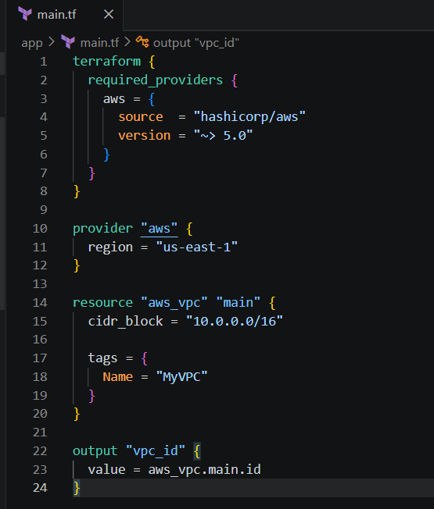
Terraform initterraform planterraform apply
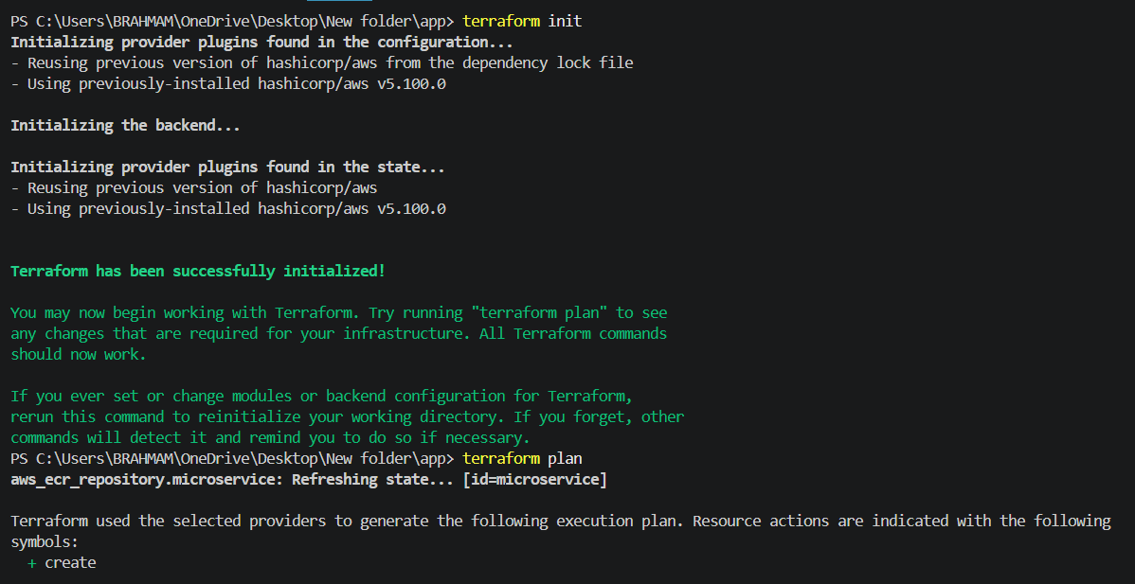
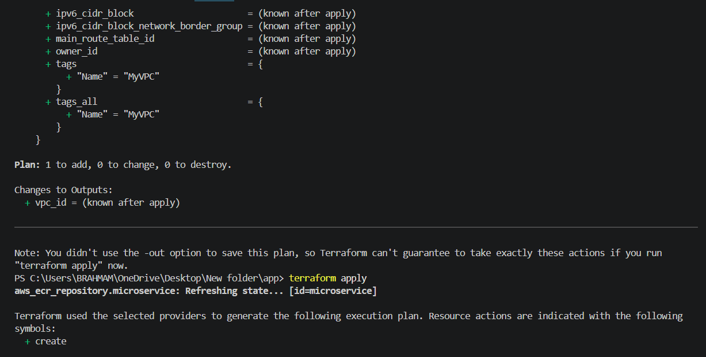
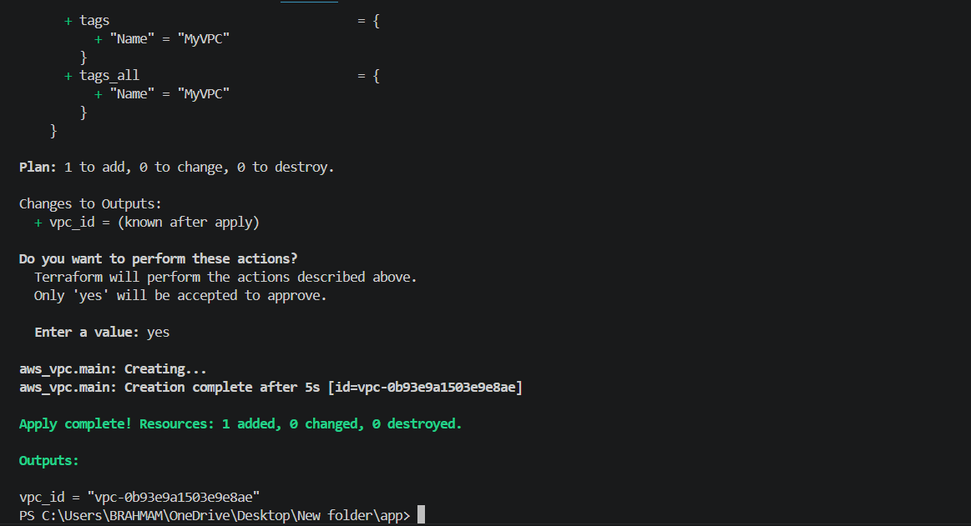
- Created myvpc success
- A VPC with the CIDR block 10.0.0.0/16 was successfully created. This VPC serves as the base network for all subsequent resources in the project.
2) Create Internet gateway
Objective
To create and attach an Internet Gateway to the VPC.
Description
An Internet Gateway allows communication between the VPC and the internet. It is
required for resources in public subnets that need internet access.
- Lets create main.tf

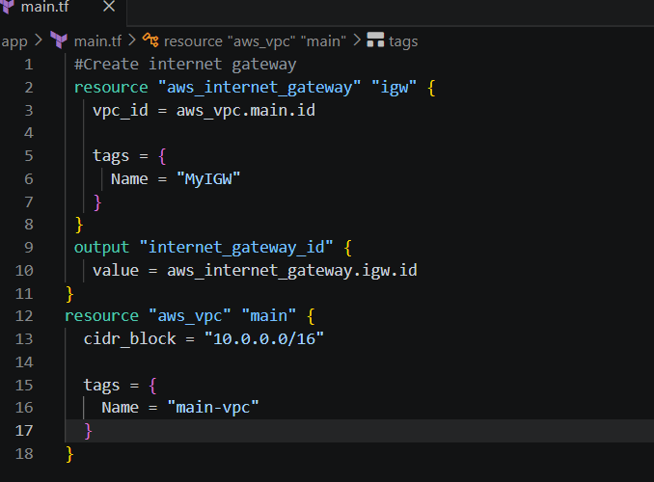
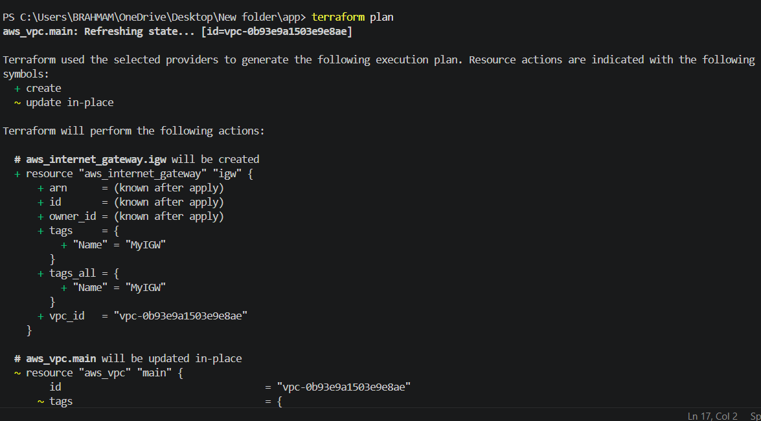
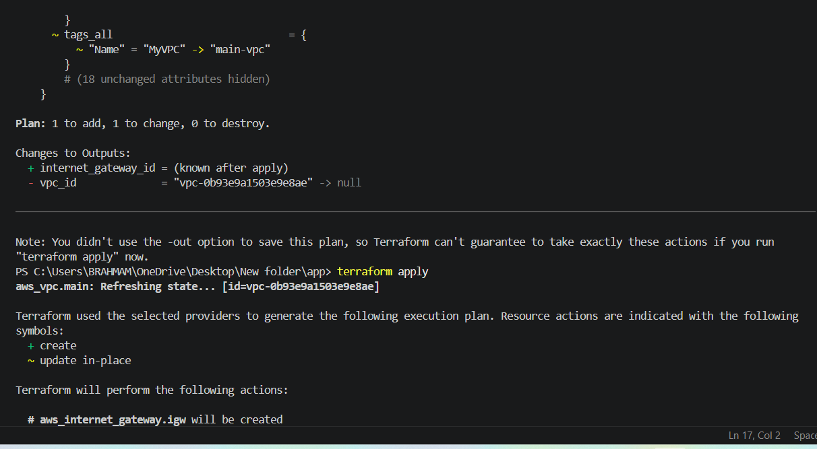
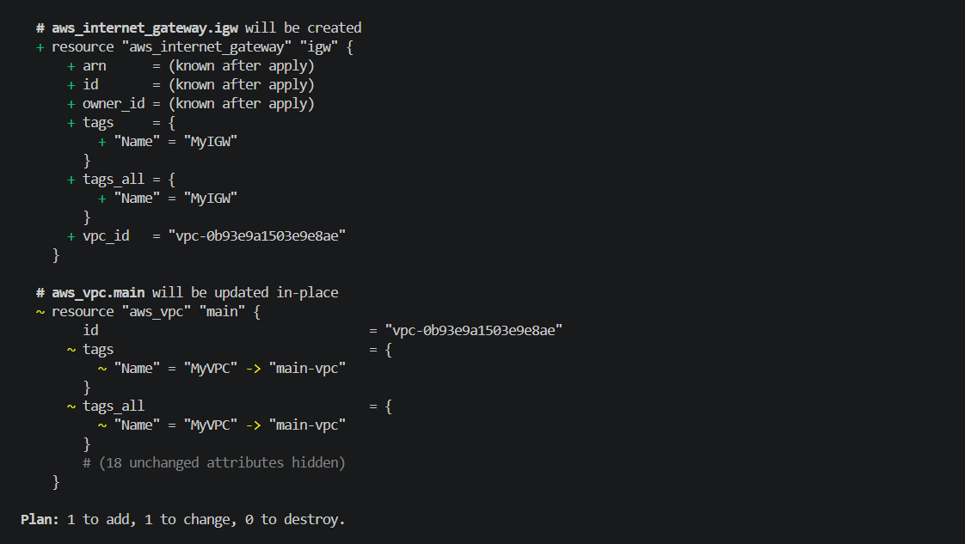
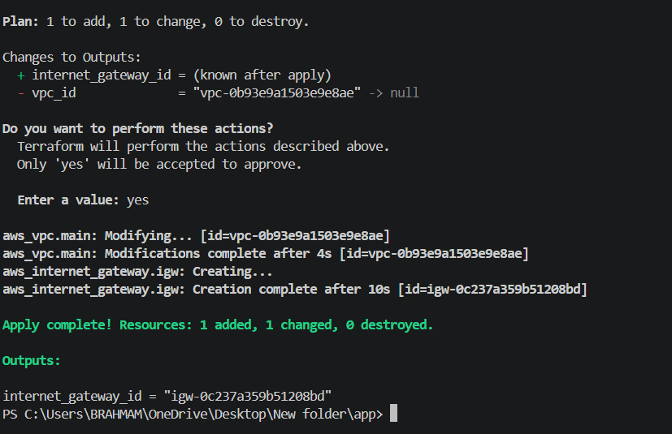
An Internet Gateway was successfully created and attached to the VPC. The VPC is now
capable of supporting internet connectivity through appropriate routing configurations.
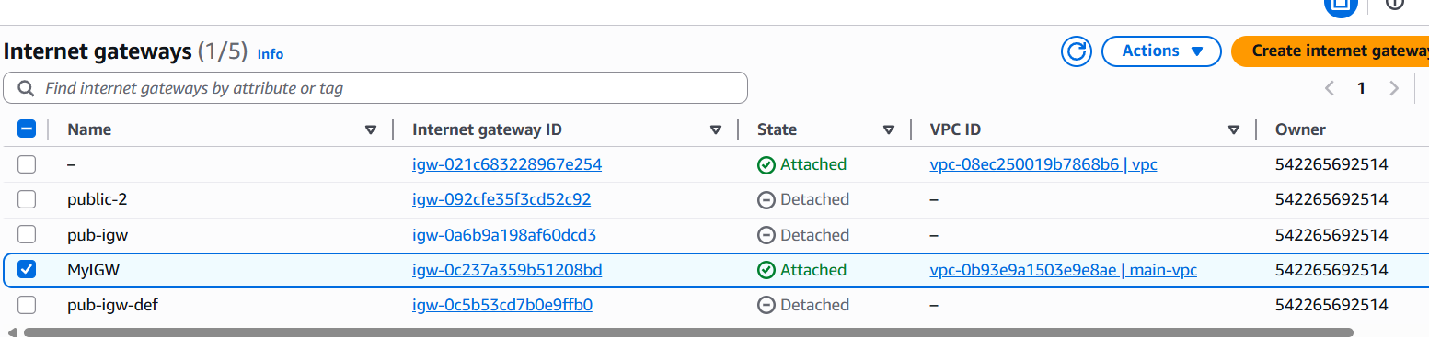
3) Create Custom Route Table.
Objective
To create a custom route table and configure a default route to the Internet Gateway.
Description
A route table contains rules that determine where network traƯic is directed. By adding a
default route (0.0.0.0/0) to the Internet Gateway, internet-bound traƯic can be routed
outside the VPC.
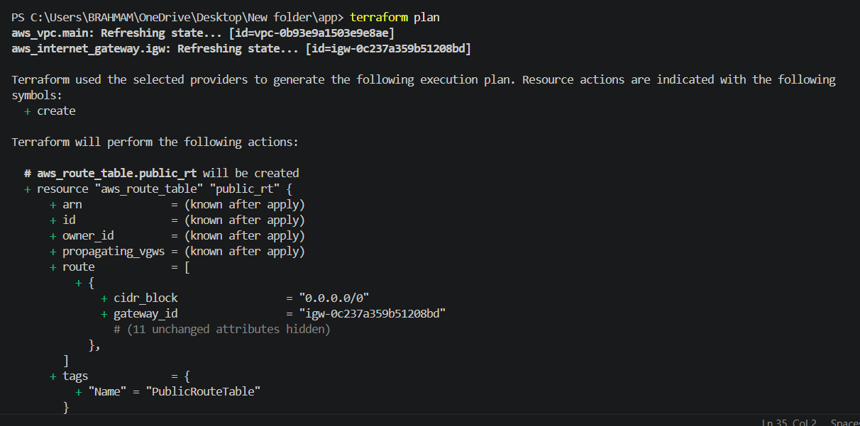
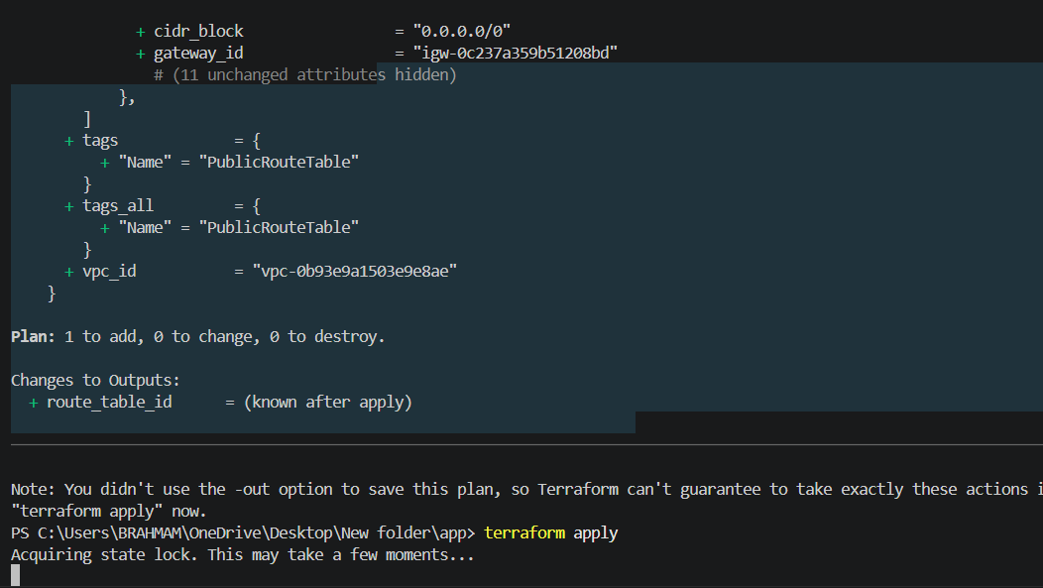

4.Create Subnet
Objective
To create a subnet within the VPC for hosting AWS resources.
Description
A subnet is a range of IP addresses within a VPC. It allows you to organize and isolate
resources within specific Availability Zones. In this task, a public subnet is created using
the CIDR block 10.0.1.0/24.
Terraform Resource Used - aws_subnet
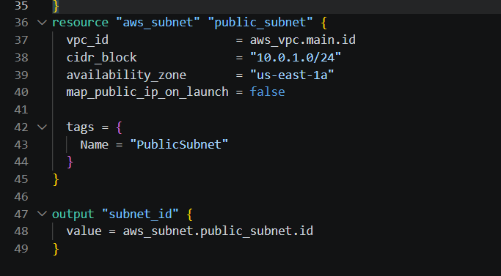
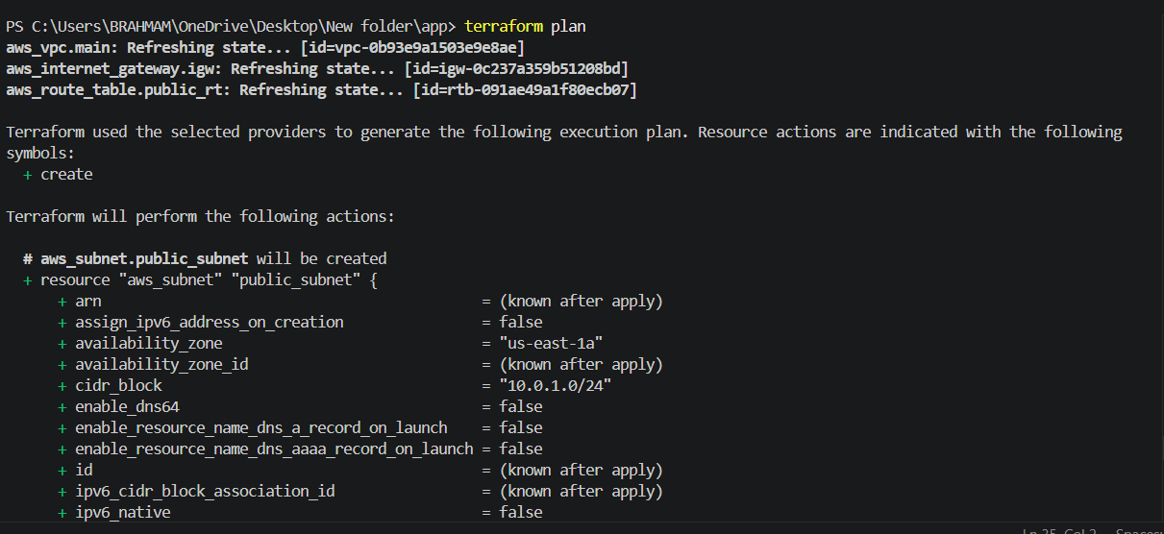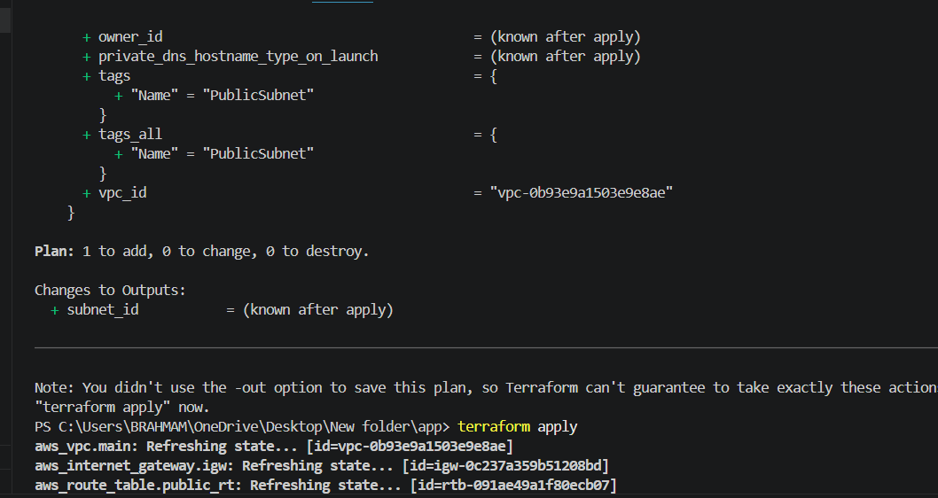
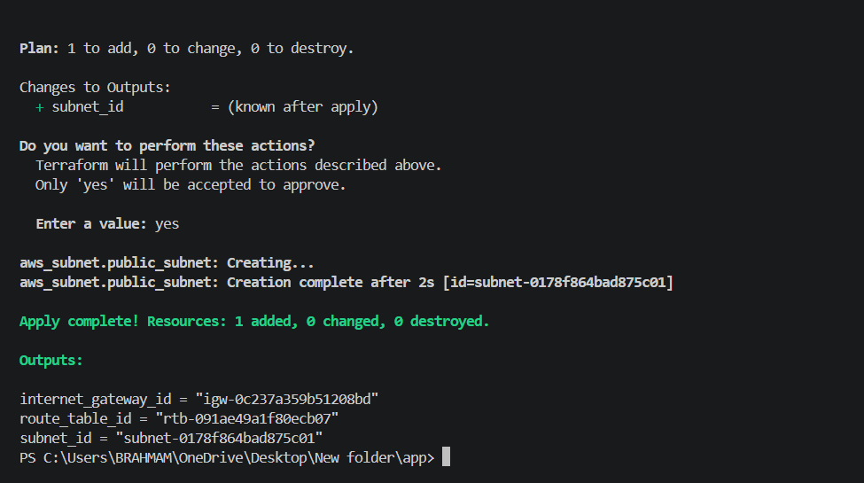
Created successfully subnet
5. Associate subnet with Route Table
Objective
Associate the subnet with the custom route table so that the subnet follows the routing
rules defined in the route table.
Description
A route table association links a subnet to a route table. Since the custom route table
contains a default route to the Internet Gateway, associating the subnet with it enables
resources in that subnet to use those routing rules.
Terraform Resource Used : aws_route_table_association
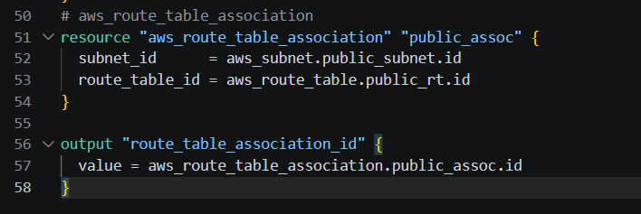
Explanation
- aws_route_table_association creates an association between a subnet and a route table.
- subnet_id = aws_subnet.public_subnet.id refers to the subnet created in the previous step.
- route_table_id = aws_route_table.public_rt.id refers to the custom route table created earlier.
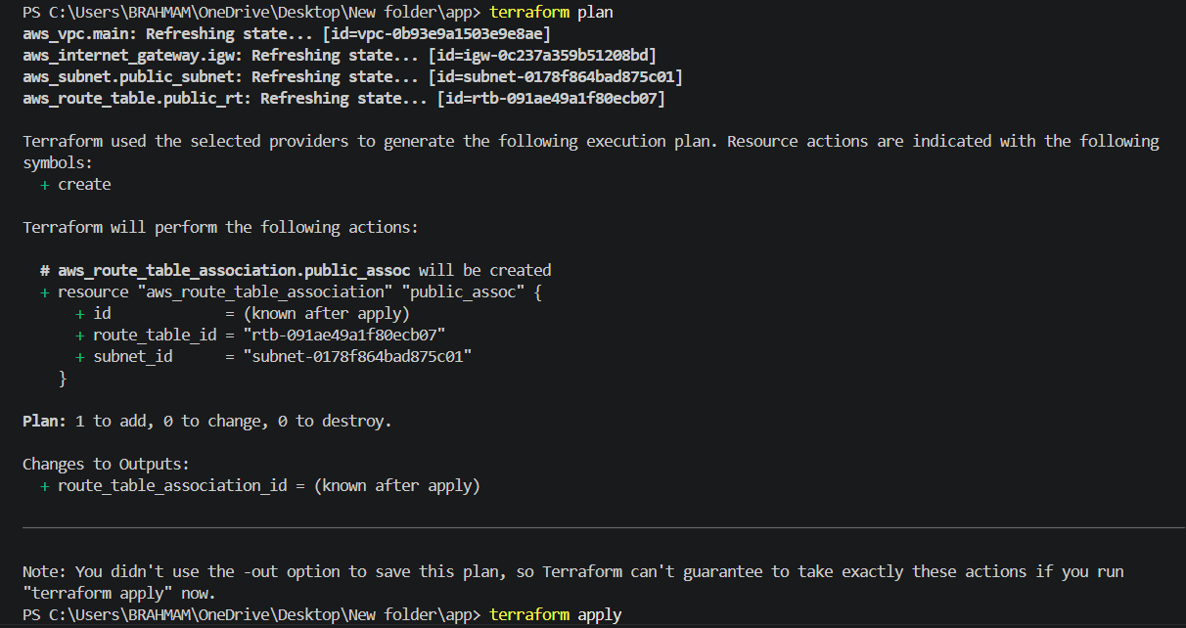
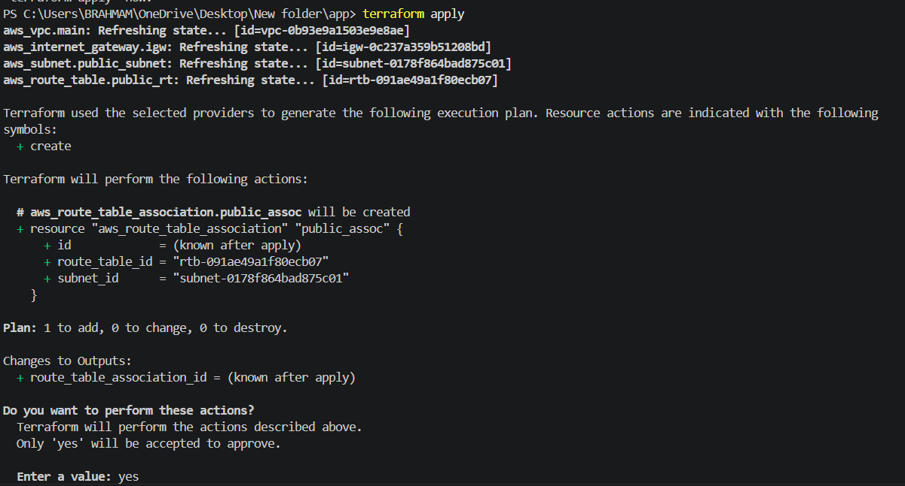
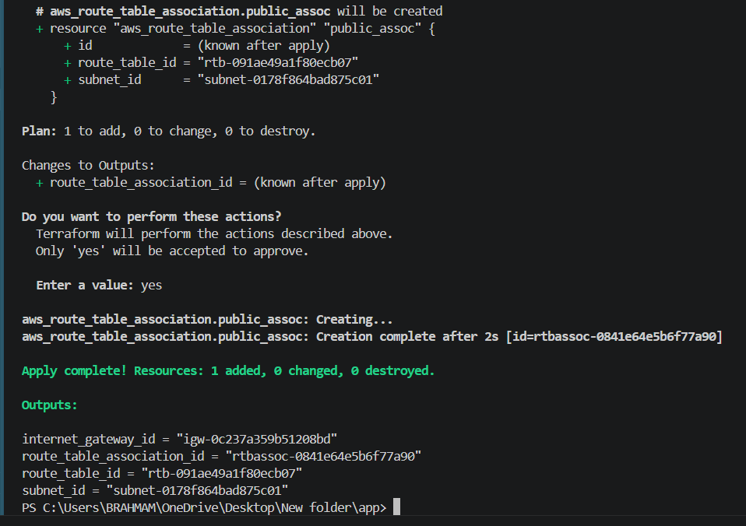
The subnet was successfully associated with the custom route table. As a result, the subnet inherits the route table's configuration, allowing internet-bound traffic to be directed through the Internet Gateway.
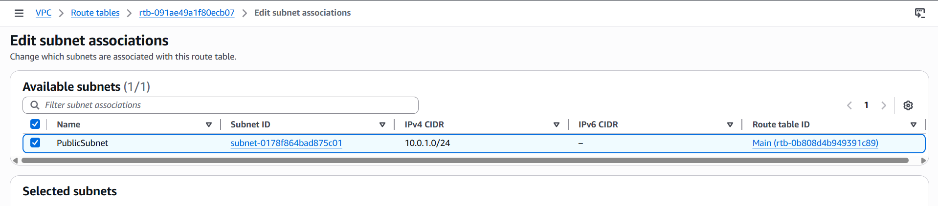
6. Create Security Group to allow port 22.80,443
Objective
Create a Security Group that permits inbound SSH, HTTP, and HTTPS traffic to resources within the VPC.
Description
A Security Group acts as a virtual firewall for AWS resources. It controls inbound and outbound traffic at the instance level. In this task, inbound access is allowed for:
- Port 22 (SSH): Remote administration of the EC2 instance.
- Port 80 (HTTP): Web traffic for Apache.
- Port 443 (HTTPS): Secure web traffic.
Terraform Resource Used : aws_security_group
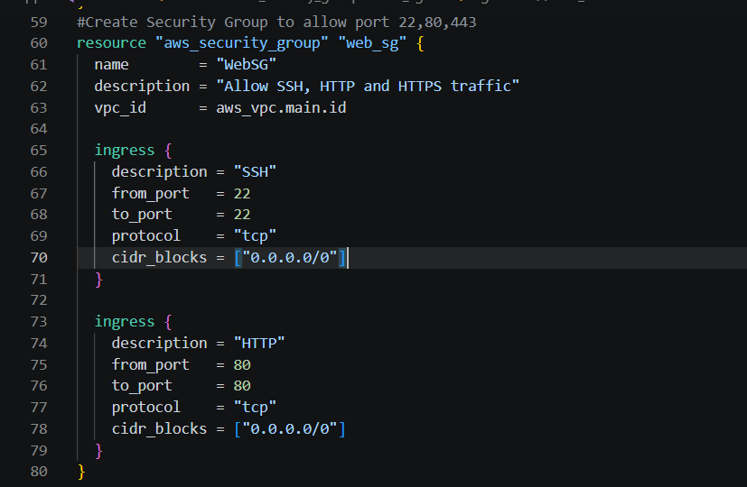
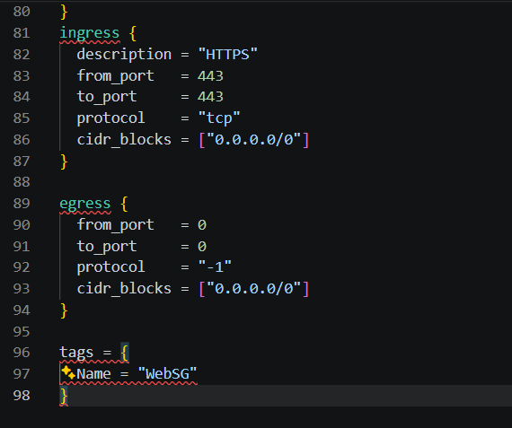
Explanation
- aws_security_group creates a security group within the VPC.
- vpc_id = aws_vpc.main.id associates the security group with the VPC.
- Three ingress rules allow:
o Port 22 for SSH access.
o Port 80 for HTTP traffic.
o Port 443 for HTTPS traffic.
- The egress rule allows all outbound traffic.
- The tags block assigns a name to the security group.
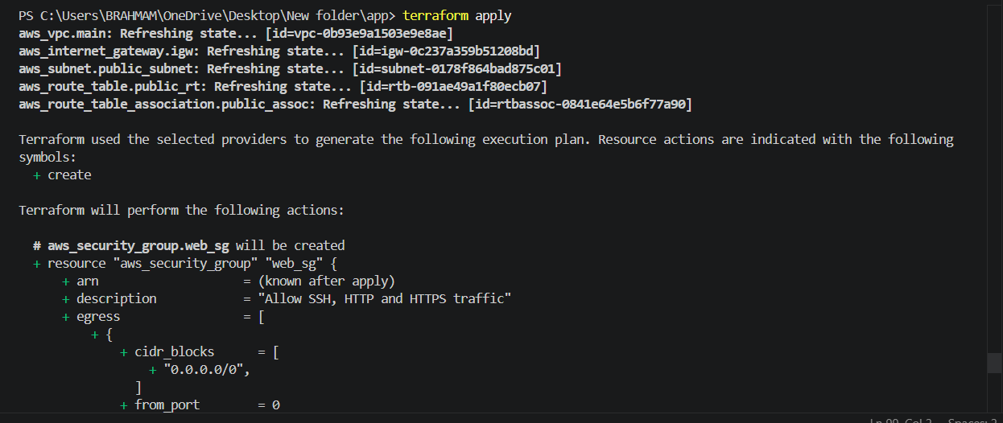
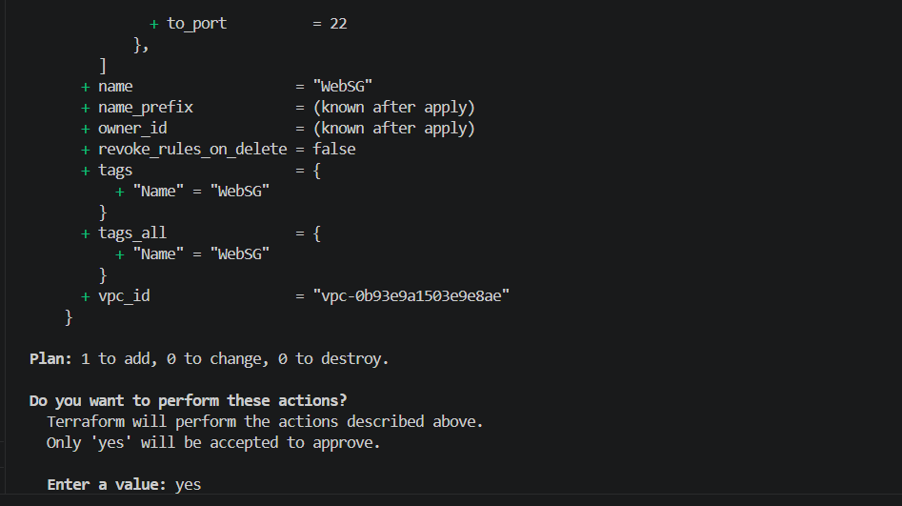
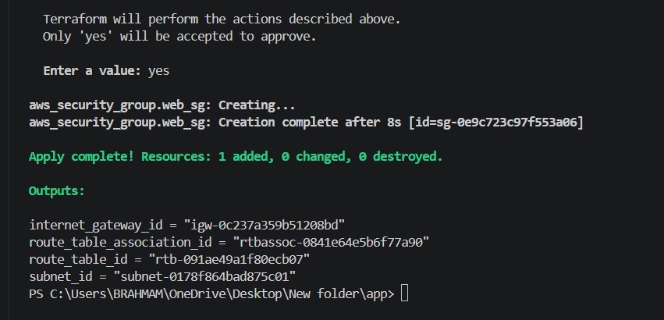
A Security Group was successfully created and configured to allow inbound SSH (22), HTTP
(80), and HTTPS (443) traƯic while permitting all outbound traƯic. This security group will be
attached to the EC2 instance in subsequent steps. 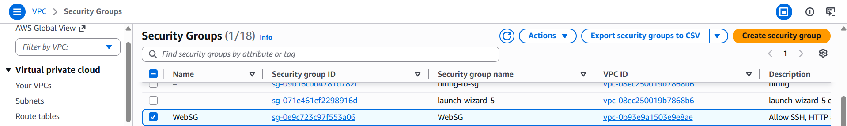
7. Create a network interface with an ip in the subnet that was created in step 4
Objective
Create an Elastic Network Interface (ENI) within the subnet created earlier and assign it a
private IP address.
Description
A Network Interface (ENI) is a virtual network card that can be attached to an EC2 instance.
It allows you to define networking attributes such as private IP addresses and security
groups independently of the instance.
In this task, an ENI is created in the public subnet and assigned the private IP address
10.0.1.10.
Terraform Resource Used : aws_network_interface
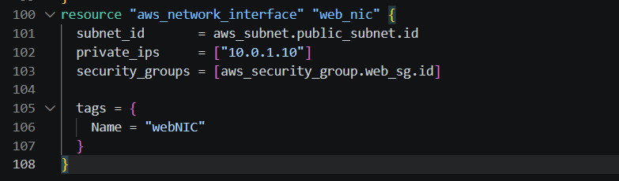
Explanation
- aws_network_interface creates an Elastic Network Interface.
- subnet_id = aws_subnet.public_subnet.id places the ENI in the subnet created in
- Step 4.
- private_ips = ["10.0.1.10"] assigns a static private IP address to the interface.
security_groups = [aws_security_group.web_sg.id] attaches the security group
created in Step 6.
The tags block provides a name for easier identification
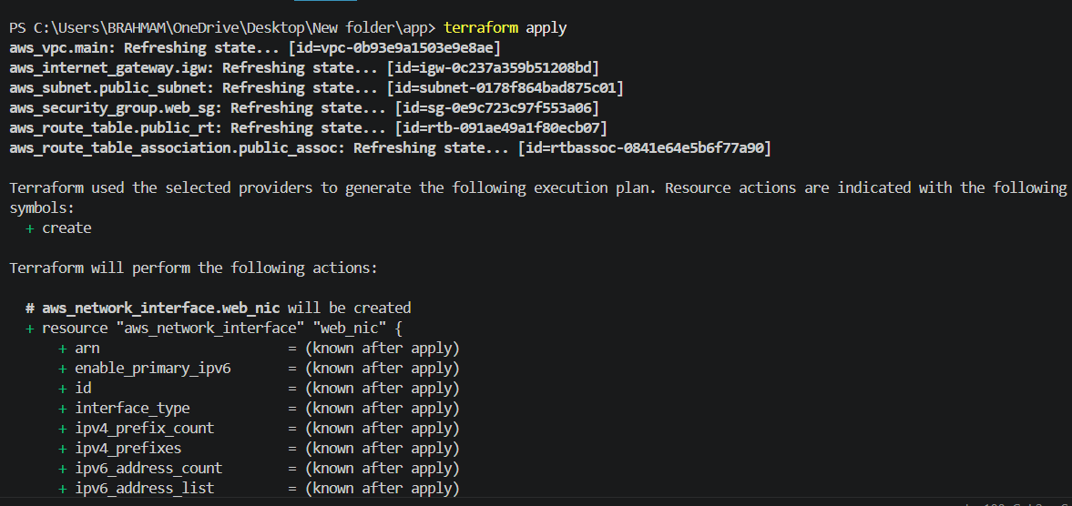
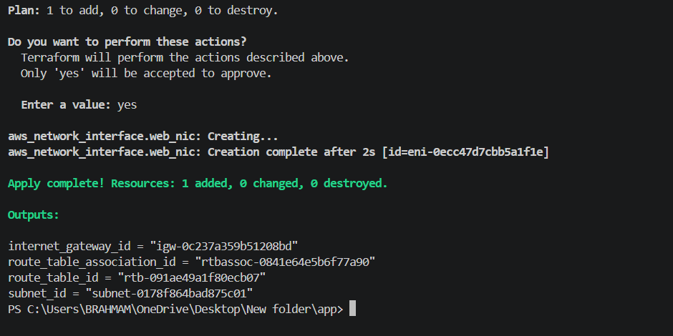
An Elastic Network Interface was successfully created within the subnet and assigned
the private IP address 10.0.1.10. The interface was also associated with the previously
created Security Group to control inbound and outbound traƯic.
To check in aws - Go to EC2. - In the left navigation pane, under Network & Security, click
Network Interfaces
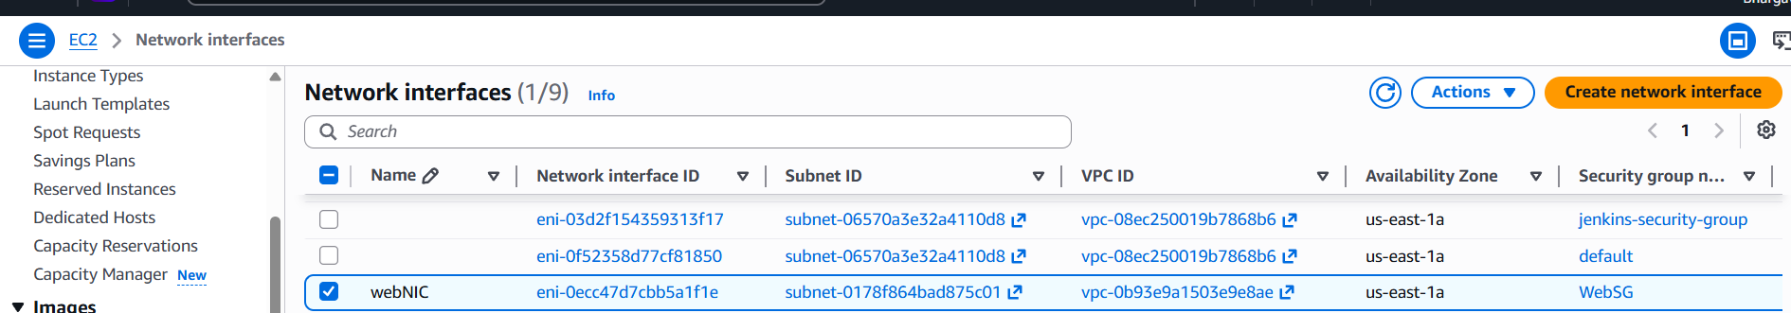
8. Assign an elastic IP to the network interface created in step 7
Objective
Allocate an Elastic IP (EIP) and associate it with the Network Interface created in Step 7.
Description
An Elastic IP is a static public IPv4 address provided by AWS. Associating it with the
Network Interface allows the EC2 instance to be accessed from the internet using a fixed
public IP address.
Terraform Resources Used :
aws_eip
aws_eip_association
main.tf
resource "aws_eip" "web_eip" {
domain = "vpc"
tags = {
Name = "WebEIP"
}
}
resource "aws_eip_association" "eip_assoc" {
allocation_id = aws_eip.web_eip.id
network_interface_id = aws_network_interface.web_nic.id
private_ip_address = "10.0.1.10"
}
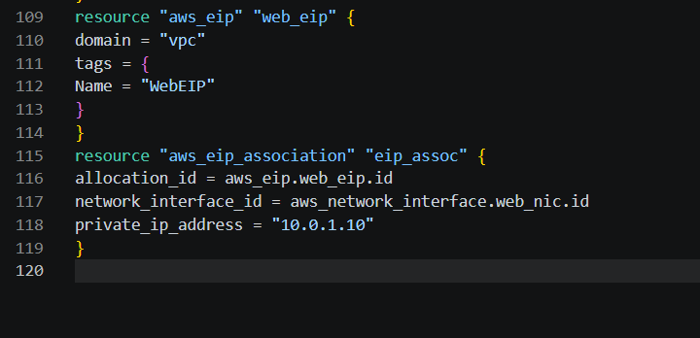 Explanation
- aws_eip allocates a new Elastic IP address.
- domain = "vpc" specifies that the EIP is for use within a VPC.
- aws_eip_association associates the Elastic IP with the Network Interface created in Step 7.
- private_ip_address = "10.0.1.10" specifies the private IP on the ENI to which the EIP should be mapped.
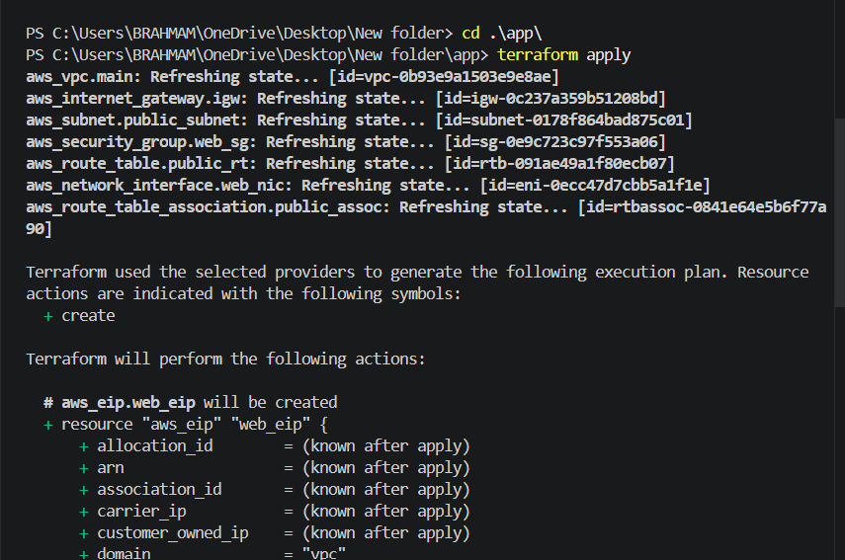
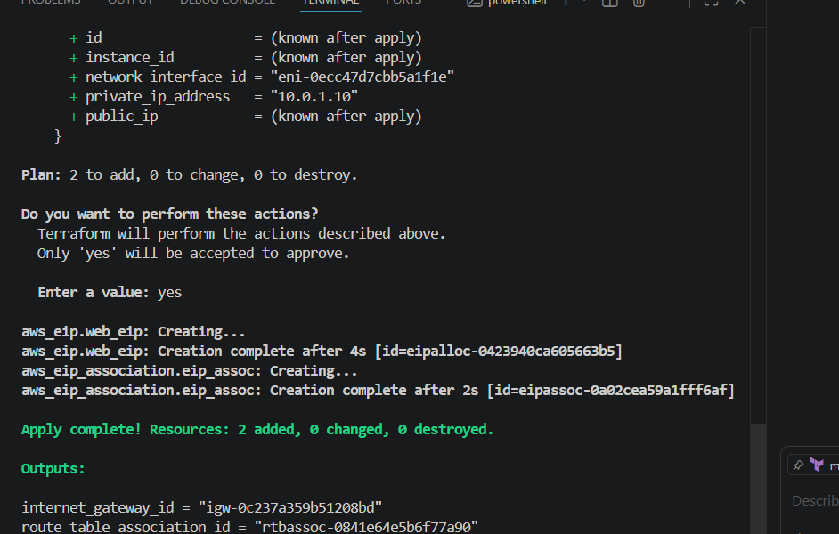
An Elastic IP address was successfully allocated and associated with the Network Interface. This provides a persistent public IP address that can be used to access the EC2 instance from the internet.
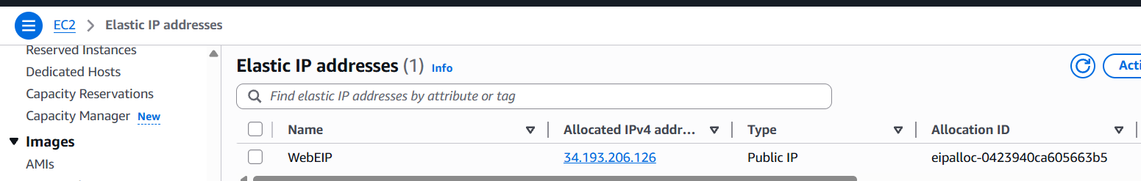
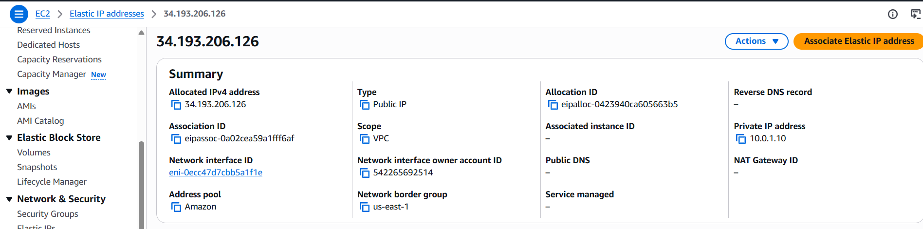
9.Create Ubuntu server and install/enable apache2
Objective
Launch an Ubuntu EC2 instance using the existing Network Interface and automatically
install and enable Apache2.
Description
An EC2 instance is created using the latest Ubuntu AMI. The Network Interface created in
Step 7 is attached to the instance, and a user data script is used to install and start the
Apache web server during instance initialization.
Terraform Resources Used :
data "aws_ami"
aws_instance
main.tf
resource "aws_instance" "web_server" {
ami = "ami-0b6d9d3d33ba97d99"
instance_type = "t3.micro"
key_name = "terraform"
network_interface {
network_interface_id = aws_network_interface.web_nic.id
device_index = 0
}
user_data = <<-EOF
#!/bin/bash
apt update -y
apt install apache2 -y
systemctl enable apache2
systemctl start apache2
EOF
tags = {
Name = "Ubuntu-WebServer"
}
}
output "instance_id" {
value = aws_instance.web_server.id
}
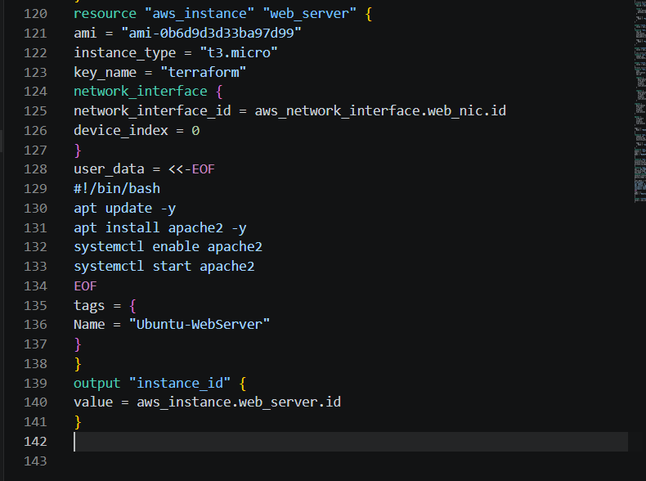
Explanation
- AMI: ami-0b6d9d3d33ba97d99
- Instance Type: t3.micro
- Key Pair: terraform
- Network Interface: Uses the ENI created in Step 7
- (aws_network_interface.web_nic)
- User Data: Installs Apache2, enables it at boot, and starts the service automatically.
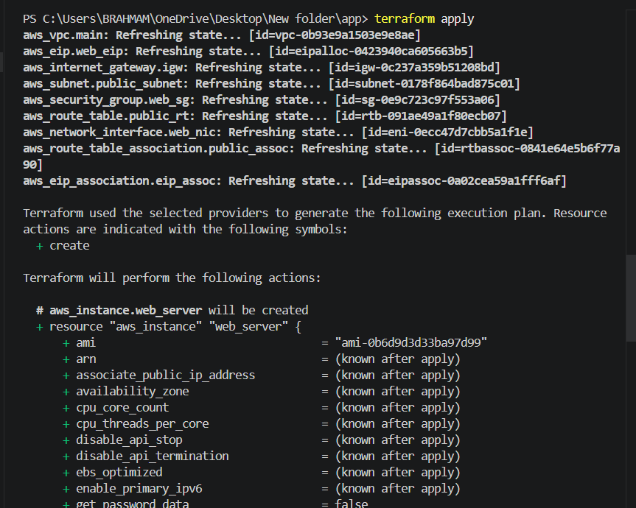
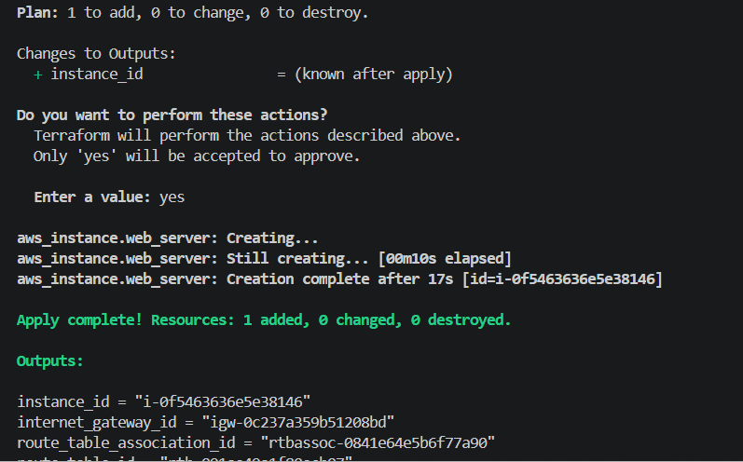
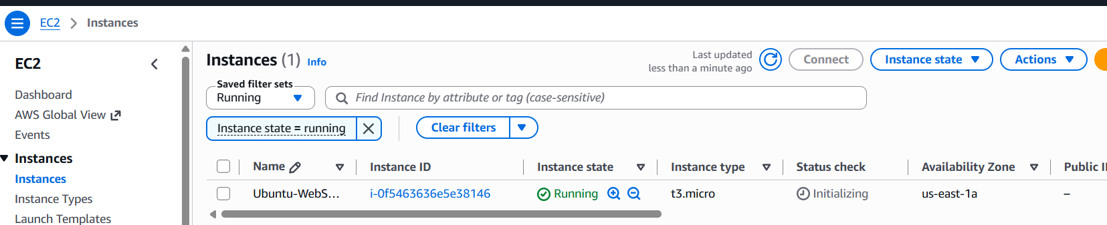
-the web server was accessible through the Elastic IP address from a web browser.

